

**YAŞAR UNIVERSITY**

**FACULTY OF ENGINEERING**

**DEPARTMENT OF COMPUTER ENGINEERING**

**COMP4910 Senior Design Project 1, Fall 2019**

**Supervisor: Dr. Gizem Kayar**

**POF: Performance Optimized Fluid System**

**Final Report**

**By:**

**Baran Budak -15070001012**

**Cihanser Çalışkan -16070001020**

**İsmail Mekan -15070001048**

# PLAGIARISM STATEMENT

This report was written by the group members and in our own words, except for quotations from published and unpublished sources which are clearly indicated and acknowledged as such. We are conscious that the incorporation of material from other works or a paraphrase of such material without acknowledgement will be treated as plagiarism according to the University Regulations. The source of any picture, graph, map or other illustration is also indicated, as is the source, published or unpublished, of any material not resulting from our own experimentation, observation or specimen collecting.

**Project Group Members:**

|  |  |  |  |
| --- | --- | --- | --- |
| **Name, Last name** | **Student Number** | **Signature** | **Date** |
| Baran Budak | 15070001012 |  |  |
| Cihanser Çalışkan | 16070001020 |  |  |
| İsmail Mekan | 15070001048 |  |  |

**Project Supervisors:**

|  |  |  |  |
| --- | --- | --- | --- |
| **Name, Last name** | **Department** | **Signature** | **Date** |
| Gizem Kayar | Computer Engineering |  |  |

# ACKNOWLEDGEMENTS

We would like to thank Gizem Kayar for discussions and suggestions in the development of the project. This project is supported by Yasar University Computer Engineering Department.

# 

# KEYWORDS

|  |  |
| --- | --- |
| **Term** | **Description** |
| **Cell** | Axis aligned bounding box is divided into small identical cubes. |
| **Color field quantity** | It is a functionthat calculates how each particle is affected by all the other particles. |
| **Gradient** | The directional derivative of a scalar field gives a vector field directed towards where the increment is most, and its magnitude is equal to the greatest value of the change. |
| **Grid** | Series of vertical and horizontal lines that are used to subdivide AABB vertically and horizontally into cells in three-dimensional space. |
| **Iso-surface** | An isosurface is a 3D surface representation of points with equal values in a 3D data distribution which is the 3D equivalent of a contour line. |
| **Marching Cubes** | Marching cubes is a computer graphics algorithm, published in 1987 for extracting a polygonal mesh of an isosurface from a three-dimensional discrete scalar field. |
| **NVIDIA Flex** | NVIDIA Flex is a particle-based simulation technique for real-time visual effects created by NVIDIA company. |
| **Polygonal Mesh** | A polygon mesh is the collection of vertices, edges, and faces that make up a 3D object. |
| **Unity 3D** | Unity is a cross-platform game engine developed by Unity Technologies. Unity is used for developing video games and simulations for consoles and mobile devices. |
| **Spatial Hashing** | Spatial hashing is a technique in which objects in a 2D or 3D domain space are projected into a 1D hash table allowing for very fast queries on objects in the domain space. |

**Table 1:** Keywords

# 

# ABSTRACT

POF system aims at providing more optimized and faster surface identification and visualization on particle-based liquid simulations. Firstly, algorithms that are necessary for the system were decided as a result of researches that had been made. Then, it was agreed to gather these algorithms. Secondly, the system was divided into a structure that has various algorithms and a control panel(controller) which administers these algorithms. While these substructures respectively, gets faster access to data; it provides memory efficiency. It determines the identification of surface and areas which to be visualized, then it visualizes. This project is research-based. So, it is possible for the structures we explain here to change and trade places with different structures. For this reason, these algorithms and structures may change later.

# ÖZET

POF sistemi parçacık temelli sıvı simülasyonlarında yüzey tanımlamasını ve görselleştirmesini daha optimize ve hızlı bir şekilde sunmayı amaçlar. İlk olarak yapılan araştırmalar sonucunda sistem için gerekli algoritmalar belirlenmiştir ve bu algoritmaların bir araya getirilerek, anlaşılması sağlanmıştır. İkinci olarak sistem çeşitli algoritmalara ve bu algoritmaları yöneten ana bir kontrol paneline sahip bir yapıya bölünmüştür. Bu alt yapılar verilere daha hızlı erişim kazanırken hafıza verimliliği sağlar. Bu altyapılar sırasıyla uzaysal verilere ulaşımın hızlanması (hash) algoritması. Yüzeyin tanımlanması ve görselleştirilecek alanların belirlenip ve ekrana çizilmesidir. Projenin araştırma temelli olmasından dolayı anlattığımız yapıların değişmesi ve yerlerine daha farklı yapıların gelmesi muhtemeldir. Bu yüzden ilerleyen zamanlarda bu algoritmalar ve yapılar değişebilir.

# TABLE OF CONTENTS

PLAGIARISM STATEMENT 1

ACKNOWLEDGEMENTS 2

KEYWORDS 2

ABSTRACT 3

ÖZET 3

TABLE OF CONTENTS 4

LIST OF FIGURES 5

LIST OF TABLES 5

LIST OF ACRONYMS/ABBREVIATIONS 5

1. INTRODUCTION 6

1.1. Description of the Problem 6

1.2. Project Goal 6

1.3. Project Output 6

1.4. Project Schedule 7

2. DESIGN 9

2.1. High Level Design 9

2.1.1 Package Diagram 9

2.2. Detailed Design 10

2.3. Realistic Restrictions and Conditions in the Design 10

3. IMPLEMENTATION and TESTS 10

3.1. Implementation of the System 10

3.1.1. Research Papers and System Structure 10

3.1.2. Implementation of Hash algorithm 11

3.1.3. Particle neighbour algorithm 12

3.2. Tests and Results of Tests 13

3.2.1. Availability of the Necessary Environment 13

4. CONCLUSIONS 13

4.1. Summary 13

4.2. Cost Analysis 13

4.2.1. Cost of Workers 13

4.2.2. Cost of Software 13

4.2.3. Cost of Hardware 13

4.2.3.1 PC components that used in Project 15

4.2.3.2. Optimal Simulation Computer 16

4.3. Benefits of the Project 16

4.3.1 Animations and Movies 16

4.3.2 Scientific work 16

4.3.3 Games 16

4.3.4 Construction 16

4.4. Future Work 16

References 17

APPENDICES 18

**Table 2:** Table of Contents

# LIST OF FIGURES

Figure 1: Package Diagram 11

Figure 2: Cell id numbering 13

Figure 3: Group struct 13

Figure 4: Hash size 13

Figure 5: Intersection boundaries check 14

Figure 6: Finding Corner Cells 14

Figure 7: Finding Dimensional Cell Count 14

Figure 8: Finding Cell Numbers in Spesific area 14

# LIST OF TABLES

Table 1: Keywords 3

Table 2: Table of Contents 5

Table 3: List of acronyms/abbreviations 6

Table 4: Problem & Solution 11

Table 5: Cost Analysis of Workers 15

Table 6: Cost of Software 15

Table 7: Component cost of PC1 15

Table 8: Component costs of PC2 15

# LIST OF ACRONYMS/ABBREVIATIONS

|  |  |
| --- | --- |
| **AABB** | Axis Aligned Bounding Box. Bounding volume for a set of objects is a closed volume that completely contains the union of the objects in the set. |
| **API** | Application Programming Interface. |
| **CPU** | Central Processing Unit. |
| **GPU** | Graphic Processing Unit. |
| **OPENGL** | Open Graphics Library is a cross-language, cross-platform application programming interface for rendering 2D and 3D vector graphics. |
| **POF** | Performance Optimized Fluid |
| **SSF** | Screen Space Fluids Pro |
| **MVC** | Stands for Model View Controller. MVC is an application design model comprised of three interconnected parts (Model, View, Controller). |

**Table 3:** List of acronyms/abbreviations

# 1. INTRODUCTION

This section gives main points about problem description, project goal and project output.

# *1.1. Description of the Problem*

The main problem of the particle-based fluid simulation system is excessive numbers of the particles. There are millions of particles in a small number of liquids such as water. A particle is a rigid body sphere. Simulation applies physics to particles and these particles act as a liquid. Simulation having difficulties in calculations predicated on a surplus of particles. Indirectly, time and memory complexity increasing.

# *1.2. Project Goal*

The main goal of the project researches whether there is a way to enhance fluid simulation. Increasing the efficiency and performance of an existing particle-based fluid simulation is a major goal. We aim to achieve these goals by implementing a variety of methods to the POF system such as using special structures to find store particles and visualize it by using various methods like the Marching cubes. In our project, there is no certain way because it is a research and development project and new more effective ways can be found during the project. Various methods and techniques will be researched and implemented while the project is in the development process.

# *1.3. Project Output*

* Better performance.
* Better memory efficiency.
* Fluid-like appearance and behaviour.
* Testing of different algorithms for performance and efficiency.
* Higher frame rates per second.

# 2. DESIGN

This section describes about design of the POF system. High level and detailed designs are explained. Restrictions and conditions mentioned in this section.

# *2.1. High Level Design*

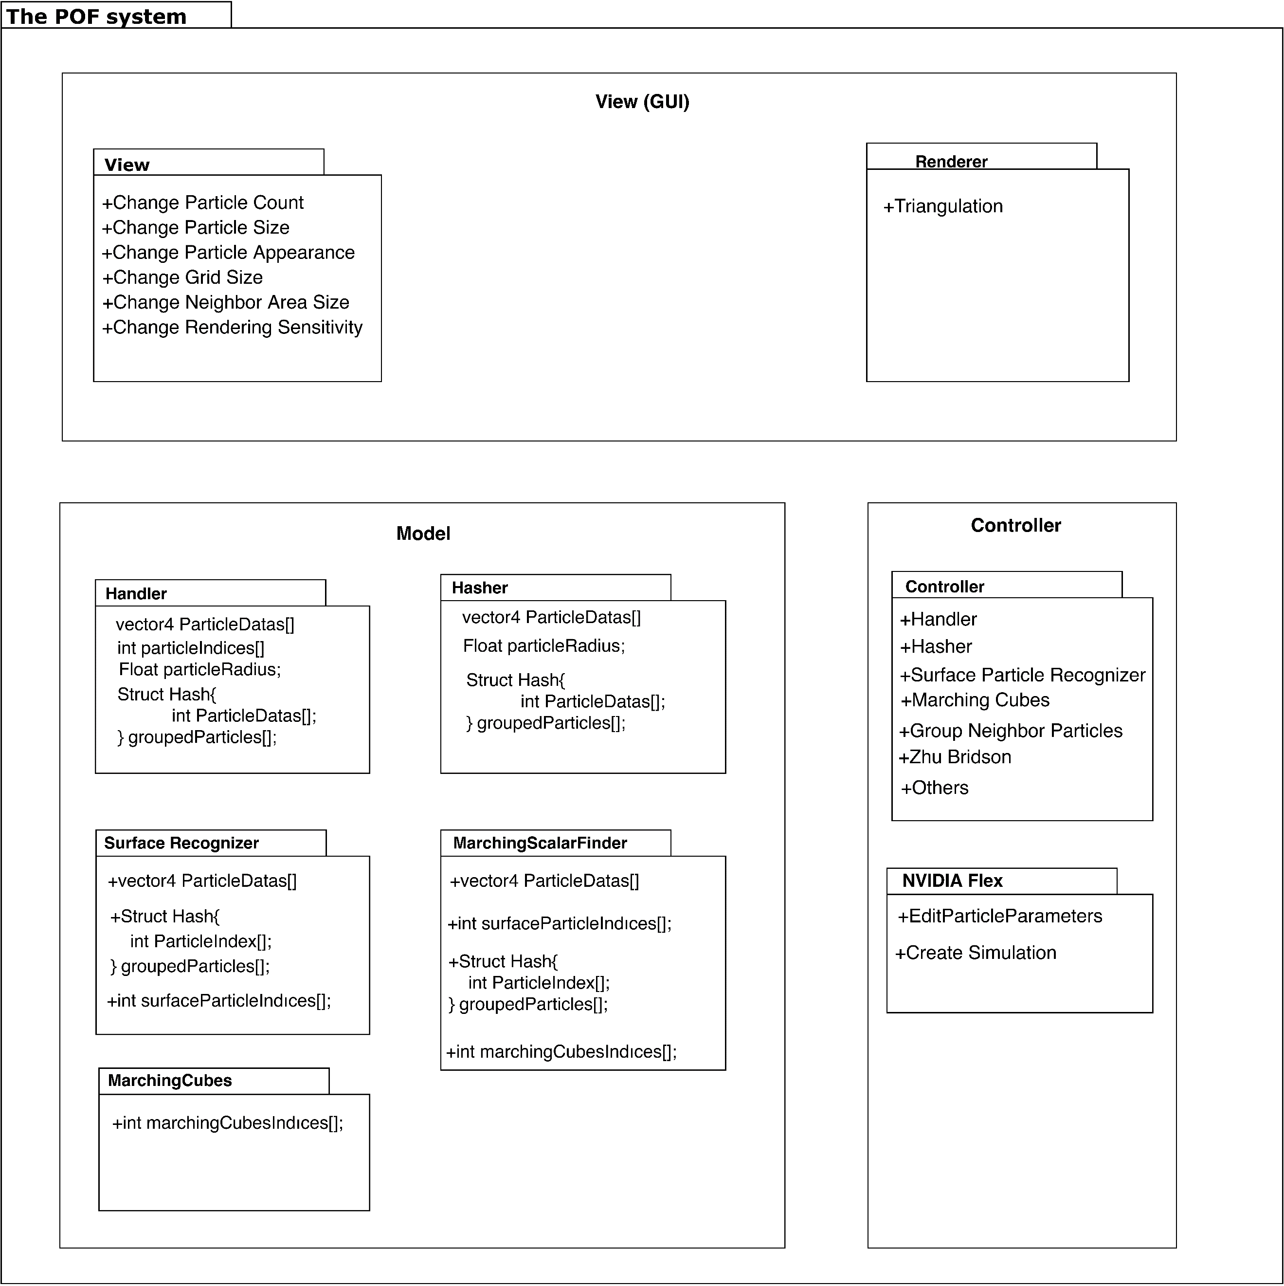***2.1.1. Package Diagram***

**Fig 1:** Package Diagram

Package diagram explains classes and their attributes along with relations. NIVIDA flex and Handler classes are the main parts of the system. Handler communicates to transmit data to relevant classes.

This section is extensively explained in design specification document [3] and it will be elaborated in future.

# *2.2. Detailed Design*

Detailed design part is mentioned in design specification document. In DSD, [3] detailed design is explained with activity diagrams of the POF system. This section will be elaborated in future works.

# *2.3. Realistic Restrictions and Conditions in the Design*

We had to neglect some aspects of the project to implement the project in a year. The security issue is ignored because the project aims to help everybody who has interested fluid simulations and contribute to science. We assumed that users of the POF system have the necessary equipment and software and know to how to use them.

# 3. IMPLEMENTATION and TESTS

This section describes implementation stages of the POF system. Code parts are given

# *3.1. Implementation of the System*

***3.1.1. Research Papers and System Structure***

This project based on these two research papers, surface reconstruction algorithm that implemented by Zhu et al [ZB05] and Marching cubes algorithm [WH87]. However, some problems occur when system structure creation stage is started on visualization. Our main problem was performance and memory efficiency on that point, we added two algorithms to our project for passing over on performance and memory issues.

**Main Problem Solution of Problem**

|  |  |
| --- | --- |
| Searching particle data linearly due to 3D space positions and vector3 to integer translation. | Spatial hashing algorithm provides reaching particles by put them into cell data. |
| Too many particles appear in simulations and handling all of them occurs performance problems. | Do not put into calculations inactive and unnecessary particle on visualization (surface particle finding algorithm). |

**Table 4:** Problem & Solution

After these solutions, we have started implement our system structure by creating classes, but we realize complexity getting higher due to interconnection between classes, so we create a handler class for control every classes in the one class.

***3.1.2 Implementation of Hash algorithm***

We use spatial hash algorithm to access particle position easily. Hash algorithm simplifies the three dimensions of float particle positions to integer id numbers in specific order.

Cube numbering is starts from top left and from left to right and then top to bottom. Then it implies the same operation for the third dimension. On x dimension, we found cell id by subtract minimum boundary area x from particle x, so it means that numbering increases from left to right. Same logic implies on y dimension, cell id number increase from top to bottom and similarly cell id number increases from backward to forward in z dimension.



**Fig 2:** cell id numbering

We can reach cell id by position without storing it.



**Fig 3:** Group struct



**Fig 4:** Hash size

Vertex index struct represents cells by creating an array on this struct. We created cell ids as indices. By finding how many grids in each dimension we find our hash table size represented as fig.4. We find particles by looking cells. Each cell represented by integer id number as seen in fig.3.

We have realized during the implementation when particle centre on intersection point of cell boundaries. We solve this problem by calculating subtract particle x/y/z from boundary max x/max y/max z and divide our grid size. If the remainder is equals to zero is on the boundary.



**Fig 5:** Intersection boundaries check.

For example, in fig. 5. we found that particle on intersection boundaries and we found its second cell on y dimension

So that way we can find the particles by looking in cells instead of linear search of the particles. Ceiling is implemented to derive integer numbers because particles are float and they are derived according to the AABB size.

***3.1.3 Particle neighbour algorithm***

We must find the effect of the particles in a range on a specific particle and calculate it for each particle. In order to think mathematically consistent and coherent with the particles, the shape of the volume that we are checking should be spherical. However, required time and finishing the project according to given time interval has compelled project team to search cubical volumes. We must look the hashed cell ids in volume that we are searching to find neighbour particles.

We need four corner cells to solve the problem of finding neighbour particles.



**Fig 6:** Finding corner cells.

These three cell borders are called as tx,ty and tz.



**Fig 7:** Finding dimensional cell count

We find grid intervals that cells are going towards in every dimension. So that way we can find all cells in this volume just by looking at one cell that we have grouped neighbour particles in that cell.



**Fig 8:** Finding cell numbers in that area.

This project is not finished. Therefore, this section will be completed in future works.

# *3.2. Tests and Results of Tests*

***3.2.1 Availability of the Necessary Environment***

Before finding NVIDIA Flex, we have tested three particle-based fluid simulation and we disqualify for these reasons.

|  |  |
| --- | --- |
| **uFlex** | Had small bugs and errors in the code, even though we have fixed minor bugs, the particles were not recognizing the collider of the objects. Collider of the simple primitive objects was not recognized by the Uflex and particles were penetrating the objects. The only plane object was being recognized by the uFlex. The problem could not be solved, and we have changed the fluid simulation. |
| **Obifluid** | Obifluid is eliminated because of performance problems. The expected result was not satisfied by the Obifluid compared to other fluid simulations our expectation was reaching 30fps with a hundred thousand particles but in three thousand particles we have 3fps. |
| **Screen Space Fluids Pro** | Like uFlex we recognize small bugs and errors in the code, and we fixed it, but performance was very low on higher particle count. |

# 4. CONCLUSIONS

In this section, the cost table of workers is given and explained. The cost of software and hardware is given with details and benefits of the projects are explained. This part of the final report summarizes our project and gives a cost analysis for the project. Future works mentioned.

# *4.1. Summary*

The massive amounts of particles can be a computational hardship for the computer.

We implement various methods to get better results by making a research. Our project focuses on catalysing computational difficulties by increasing the performance and efficiency. Project should make easier to simulate with higher quantities of particles or getting better results with the same number of particles.

# *4.2. Cost Analysis*

***4.2.1 Cost of workers***

|  |  |  |  |  |  |  |
| --- | --- | --- | --- | --- | --- | --- |
| **Members** | **Day/Hour** | **Week/Hour** | **Semester/Hour** | **Salary/Hour** | **Salary/Monthly** | **TOTAL** |
| Member | 8 | 40 | 560 | 30 TL | 4800 TL | 16800 TL |

**Table 4:** Cost Analysis of Workers

As shown in the cost analysis table, three people works in the project. Every people work equally as workload. Therefore, only one member is represented on the cost table.

Every member works 8 hours a day and 5 days a week. A semester consists of 14 weeks and salary is 30 Turkish lira per hour. Each member costs 4800 TL per month and costs 16800 in a semester. The salary costs of all three members are 50400 TL per semester. The equivalent of 16800 TL is $2894, 67. Currency translation has made from Dollar / Turkish Lira = 1 / 5.80 in 10 December 2019.

***4.2.2 Cost of Software***

|  |  |
| --- | --- |
| **Title of Software** | **Cost** |
| uFlex | $30 |
| Obi Fluid | $30 |
| SSF | $7 |
| **Total Cost** | **$67** |
|  |  |

**Table 5:** Cost of software

***4.2.3 Cost of Hardware***

***4.2.3.1 PC components that used in Project***

Total cost = Total employee cost + Total software cost + Total Hardware cost (PC1)

|  |  |
| --- | --- |
| **PC 1 components that used in Project** | **Description** |
| Operating System | Windows 10 (64-bit) |
| Processor | Intel Core i7-4700 HQ CPU |
| Memory | 16 GB RAM – DDR3L-1600 MHz |
| GPU | NVIDIA GeForce GTX850M 4GB DDR3 |
| Cost of PC 1 per user | $1693, 21 |
| **Total cost (for 1 worker)** | **$4684, 88** |
| **Total cost (for 3 workers)** | **$14054, 64** |

**Table 6:** Component costs of PC1

***4.2.3.2 Optimal Simulation Computer (PC 2)***

Total cost = Total employee cost + Total software cost + Total Hardware cost (PC2)

|  |  |
| --- | --- |
| **Optimal Simulation Computer (PC 2)** | **Description** |
| Operating System | Windows 10(64-bit Pro) |
| Processor | 8-core Intel i7 5.1 GHz |
| Memory | 32 GB RAM- DDR4- 2666MHz |
| GPU | NVIDIA Quadro P2200 5GB |
| Cost of PC 2 per user: | $5017 |
| **Total cost (for 1 worker)** | **$8008,67** |
| **Total cost (for 3 workers)** | **$24026,01** |

**Table 7:** Component costs of PC2

# *4.3. Benefits of the Project*

Our project can benefit in all areas where liquid simulation is available.

* + 1. ***Animations and Movies:*** The POF system can be used in any movies, animations that used fluids.
    2. ***Scientific work:*** Our project benefit scientific areas the most because the project is heavily research and development based of the research papers about the particle-based fluid simulations. Scientist and researchers can use the POF system for their scientific researches.
    3. ***Games:*** Some games need a fluid simulation system to make more realistic games. The POF system can be a good factor for the makes realistic games. For instance, in sailing simulator game is a perfect match for our system.
    4. ***Construction:*** The construction and Architecture sector can benefit from our system because the simulation is physics-based which means the POF system is almost realistic. The POF system neglects some imperceptible elastic deformations. For instance, a civil engineer can build a barrage and want to test endurance, on the computer simulation. Therefore, our system can be used for construction and architecture testing.

# *4.4. Future Work*

We will develop our project in order to achieve performance and efficiency goals. The functionality of the project will remain the same. However, small changes in the calculations will be changed to get better results.

# References

1. Requirement Specification Document revision 1.0 (RSD 1.0)
2. Requirement Specification Document revision 2.0 (RSD 2.0)
3. Design Specification Document revision 1.0 (DSD 1.0)
4. **[WH87]** William E. Lorensen and Harvey E. Cline. (1987). Marching cubes: A high resolution 3D surface construction algorithm. ACM SIGGRAPH Computer Graphics. 21, 163-169.
5. **[ZB05]** Zhu, Y., & Bridson, R. (2005). Animating sand as a fluid. (New York, NY, USA, 2005) ACM Trans. Graph., 24, 965-972.

**APPENDICES**

**APPENDIX A: REQUIREMENTS SPECIFICATION DOCUMENT**

**APPENDIX B: DESIGN SPECIFICATION DOCUMENT**